Retrieved from a skip
The village on Active Service
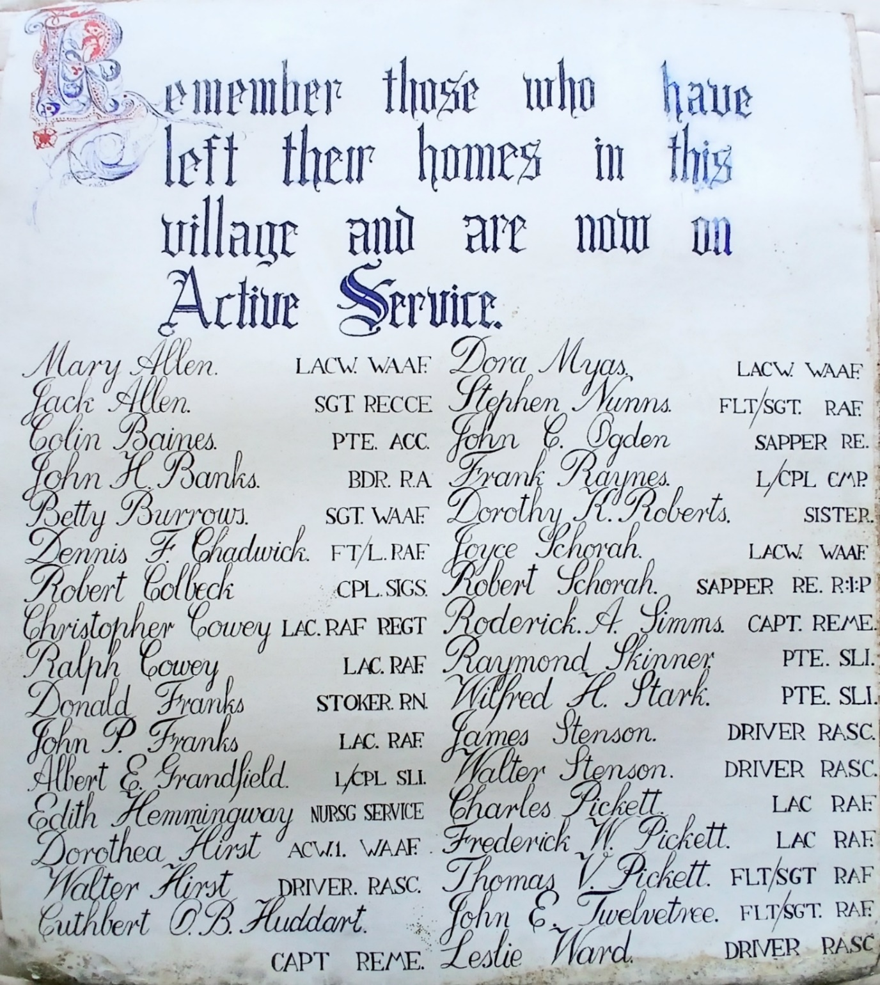

When the Church of St. Stephen, East Hardwick was being rewired in 2008 a skip was required to help with the disposal of the extensive amount of old cabling, ducting pipe etc.

At the same time a general clean up in the church provided further items to be thrown into the skip.

By chance Trevor Nichol noticed something of interest amongst the debris that he considered too important to be thrown away. He retrieved this piece of village history before it became damaged beyond repair by rain, rubble and everything else that had been thrown into the skip and lost forever.

In the 1940’s someone from the village had the calligraphy skills to pen this acknowledgement of the sacrifice being made by the villagers of East Hardwick on war Active Service. No evidence of the name of the author or the date of production is to be found.

However, a reasonable estimate for the date of the writing of the poster can be made as being sometime between the summers of 1941 and 1942. This is based on the information known of the two WWII causalities remembered on the village War Memorial.

- Robert Schorah d. 24th. April 1941
- Richard Weddall d. 2nd. August 1942

Only Robert is mentioned on the poster and is noted as ‘R.I.P.’

Is it wishful thinking that this poster might have been produced to mark Remembrance Day 1941?

* * * * *
More names of villagers would be added to those on Active Service before the war ended in 1945.

The last eighty years have seen a change of villagers and there are only a handful of family names on the poster that remain in the village.

© Roy Donaldson. May 2025

