East Hardwick Parish Council
Act of
Remembrance

Sunday 9th. November 2025
10.45 a.m. (approx.)
@
the War Memorial

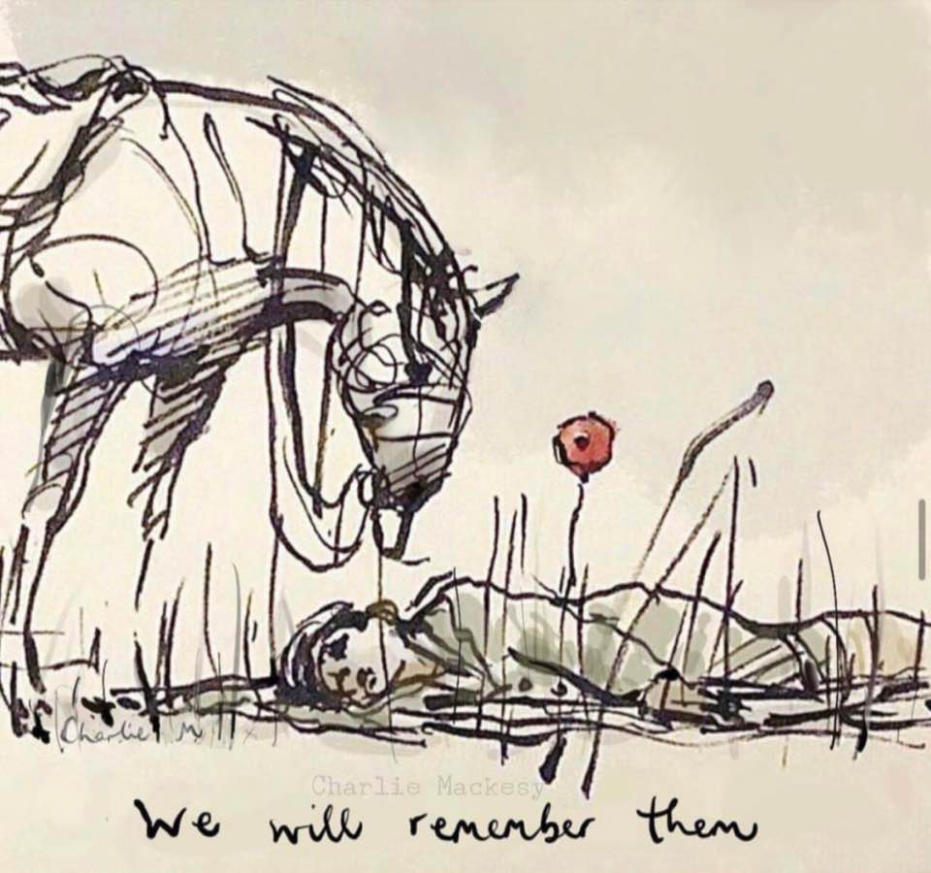

© R.D.

