East Hardwick Parish Council
War Memorial

There are only a handful of East Hardwick villagers who have any personal knowledge of the war years. For all of us it was our parents, grandparents and great-grandparents who knew the significance of VE Day 1945.
It was not the end of the war, that did not come about until after VJ Day (August 15^{th.}) when on the 2nd. September 1945 Japan formally surrendered.
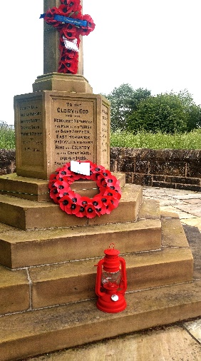
To pay tribute to the villagers of East Hardwick and our relatives who contributed in the war effort, either on Active Service or in Civilian Roles, the
Lamp of Peace
is to be lit once again at the
Village War Memorial – Thursday 8th. May @ 9.15pm.
to coincide with the national and international
‘Act of Respect’ © R.D.

